Infosys Springboard Virtual Internship 6.0 Completion Report

Team Details:

Batch Number : 6
Start date : 10-11-2025
Names :
- Rahul Kummara
- Ruchitha Mallela
Internship Duration : 8 Weeks

1. Project Title

Air Aware – Smart Air Quality Prediction System

2. Project Objective

The primary objective of the Smart AQI Monitoring and Prediction System is to design and develop a full-stack application that provides real-time air quality monitoring, accurate AQI prediction, and health-based recommendations for users across major Indian cities. The project aims to integrate real-world environmental data with machine learning techniques to analyze pollutant concentrations and forecast future air quality trends, thereby enabling users to make informed decisions regarding their health and daily activities. Additionally, the system focuses on secure user authentication, intuitive data visualization, and scalable architecture to promote public awareness about air pollution and contribute toward preventive healthcare and environmental sustainability.

3. Project description in detail

The Smart AQI Monitoring and Prediction System is a full-stack web application developed to monitor air quality levels and predict future Air Quality Index (AQI) values across major cities in India. Air pollution poses serious health risks, and timely access to accurate air quality information is essential for public awareness and preventive healthcare. This project addresses the need for a centralized platform that combines real-time data, predictive analytics, and user-friendly visualization to help users understand air pollution conditions effectively.
The system collects real-time air pollution data from reliable external sources and processes it through a robust backend infrastructure. Pollutant concentrations such as PM2.5, PM10, CO, NO₂, SO₂, and O₃ are analyzed to determine the current AQI level for a selected city. The frontend presents this information using interactive dashboards, charts, and color-coded indicators, allowing users to easily interpret air quality conditions and associated health risks.
To enhance decision-making, the project incorporates a machine learning-based AQI prediction model trained on historical air quality datasets. The model analyzes pollutant trends and predicts future AQI values over different time ranges, such as hourly, weekly, and monthly forecasts. These predictions provide valuable insights into potential pollution patterns, helping users plan activities and take precautionary measures in advance.
In addition to monitoring and prediction, the system includes secure user authentication and personalized access through login and registration functionality. Health recommendations are dynamically generated based on AQI levels to guide users on outdoor activities and safety measures. With its modular design, scalable architecture, and integration of real-world data and machine learning, the project serves as an effective tool for improving air quality awareness and promoting environmental and public health responsibility.

4. Timeline Overview

Week | Activities Planned | Activities Completed
Week 1 | Problem identification, understanding AQI concepts, and defining project objectives | Project objectives defined, AQI use case finalized, frontend layout and navigation planned
Week 2 | Frontend environment setup and basic UI development | React project initialized, routing configured, basic pages created
Week 3 | Dashboard UI development and data visualization components | AQI dashboard designed, charts and UI components implemented
Week 4 | Frontend feature enhancement and responsiveness | City selection dropdown, theme toggle, alerts, and responsive design completed
Week 5 | Backend setup and API design | Flask backend initialized, API structure designed, MongoDB connection established
Week 6 | Real-time AQI API integration and backend data processing | OpenWeather AQI API integrated, pollutant data processed and served to frontend
Week 7 | Machine learning model development for AQI prediction | Dataset preprocessing completed, ML model trained and evaluated
Week 8 | Authentication, system integration, testing, and documentation | JWT authentication implemented, frontend-backend integration tested, project documented

5(a). Key Milestones

Milestone | Date Achieved
Inauguration | 10/11/2025
Milestone - 1 | 20/11/2025 - 21/11/2025
Milestone - 2 | 04/12/2025 - 05/12/2025
Milestone - 3 | 18/12/2025 - 19/12/2025
Milestone - 4 | 30/12/2025 - 31/12/2025

5(b). Project execution details

- Requirement Analysis – Analyzed the need for real-time air quality monitoring and prediction, identified user expectations, and defined functional and non-functional requirements of the system.
- Technology Stack Finalization – Selected React.js for frontend development, Flask for backend services, MongoDB for data storage, and machine learning techniques for AQI prediction based on pollutant data.
- System Architecture Design – Designed the overall system flow including frontend–backend communication, API endpoints, database interactions, and machine learning integration.
- Data Source Integration – Integrated reliable external air quality data sources to fetch real-time AQI and pollutant concentration values for multiple cities.
- Data Cleaning and Feature Engineering – Processed historical air quality datasets by handling missing values, selecting relevant pollutants, and preparing features suitable for machine learning.
- Machine Learning Model Implementation – Developed and trained an AQI prediction model using regression techniques, evaluated its performance, and saved the trained model for real-time inference.
- Frontend Interface Development – Implemented an interactive AQI dashboard with city selection, charts, alerts, health recommendations, and responsive design.
- Backend API Development – Developed RESTful APIs to serve real-time AQI data, predicted AQI values, and authentication services, ensuring smooth data exchange with the frontend.
- System Testing and Validation – Performed functional testing, API testing, and integration testing to ensure accuracy, reliability, and error handling across the application.
- Final Deployment and Documentation – Deployed the complete system in a local/cloud environment, prepared technical documentation and user guidelines, and demonstrated the working application.

6(a). Execution Steps

Step 1 : Clone the Project Repository
Clone the project source code from the GitHub repository to your local system.
- https://github.com/infosysbatch6/Infosys-team-project-
Navigate into the project directory.
- cd Air Aware Project

Step 2 : Step up the Backend Envinornment
Move to the backend folder
- cd smart_aqi_backend
Install required backend requirements
- pip install –r requirements.txt

Step 3 : Configure Environment Variables
Create a .env file inside the backend directory and add the required keys.
- OPENWEATHER_API_KEY = your_openweather_api_key
- MONGO_URI = mongodb://localhost:27017/
- SECRET_KEY = smart_aqi_secret_key
- JWT_SECRET_KEY = smart_aqi_jwt_secret_key

Step 4 : Start MongoDB Service
Ensure MongoDB is installed and running.
- Mongod

Step 5 : Train the Machine Learning Model
Run the ML training script from the backend root directory
- python –m models.ml_model
This will generate the trained model file:
- models/aqi_predictor.pkl

Step 6 : Run the backend server
Start the Flask Backend Server
- python app.py
The backend will run at:
- http://127.0.0.1:5000

Step 7 : Set Up the Frontend Environment
Open a new terminal and navigate to the frontend folder.
- cd smart_aqi_frontend
Install frontend dependencies
- npm install

Step 8 : Run the frontend application
Start the react development server
- npm start
The frontend will open in the browser at:
- http://localhost:3000

Step 9 : Access the application
- Register a new user
- Login using credentials
- Select a city
- View real-time AQI, predictions, charts, and health recommendations

6(b). Screenshots

>> HOME PAGE

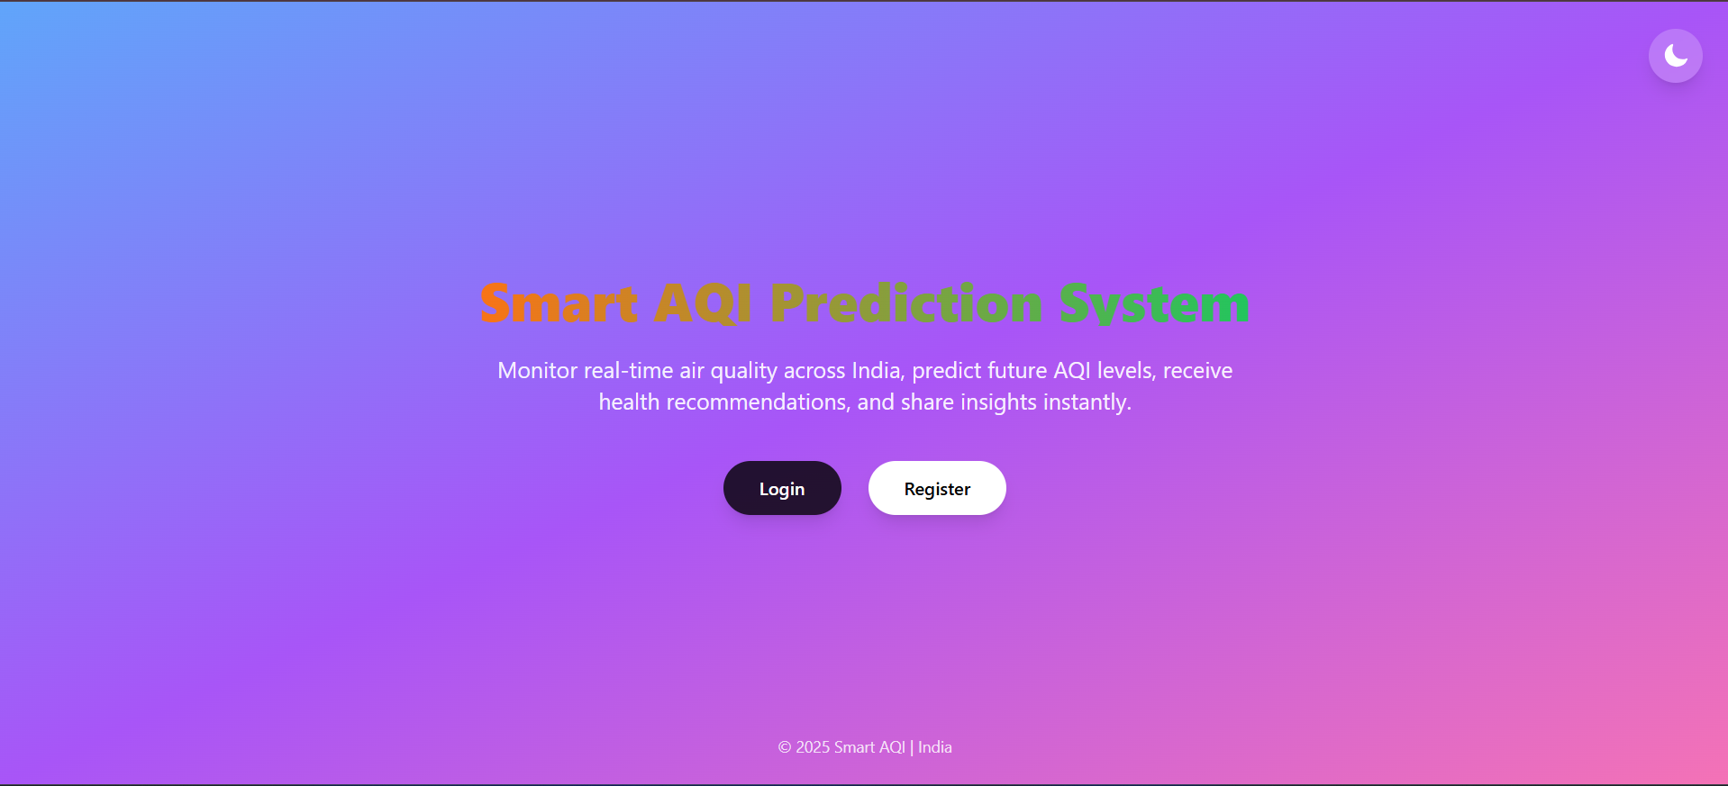
>> REGISTER PAGE >> LOGIN PAGE

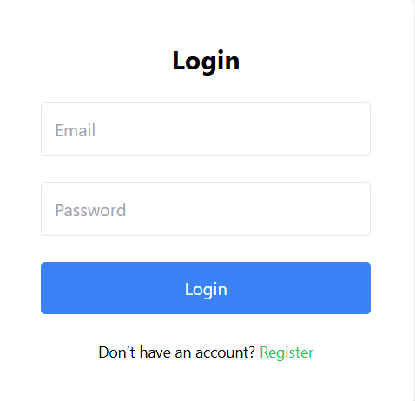

>> DASHBOARD - LIGHTMODE

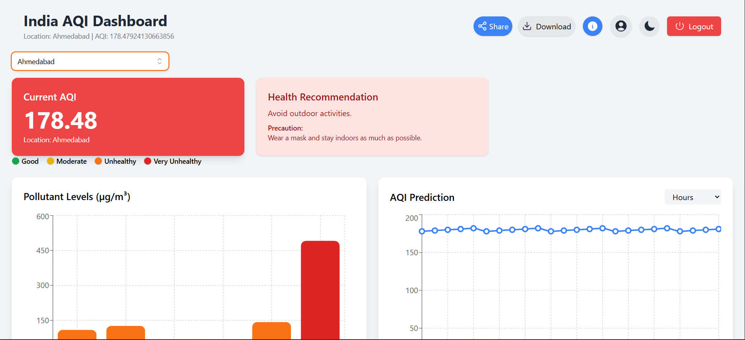

>> DASHBOARD-DARK MODE

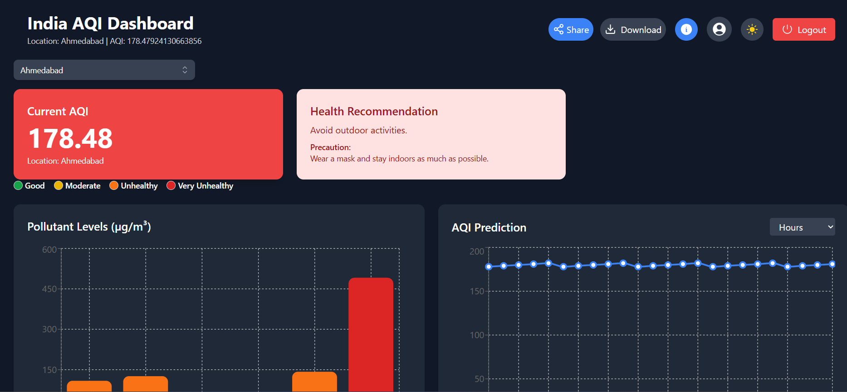

>> DROPDOWN

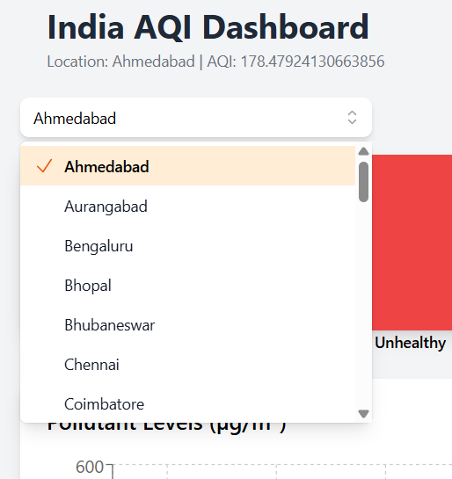

>> EXTRA FUNCTIONALITIES – Share, Download, About, Profile, Dark/Light Mode, Logout Button

>> GRAPHS AND PREDICTION

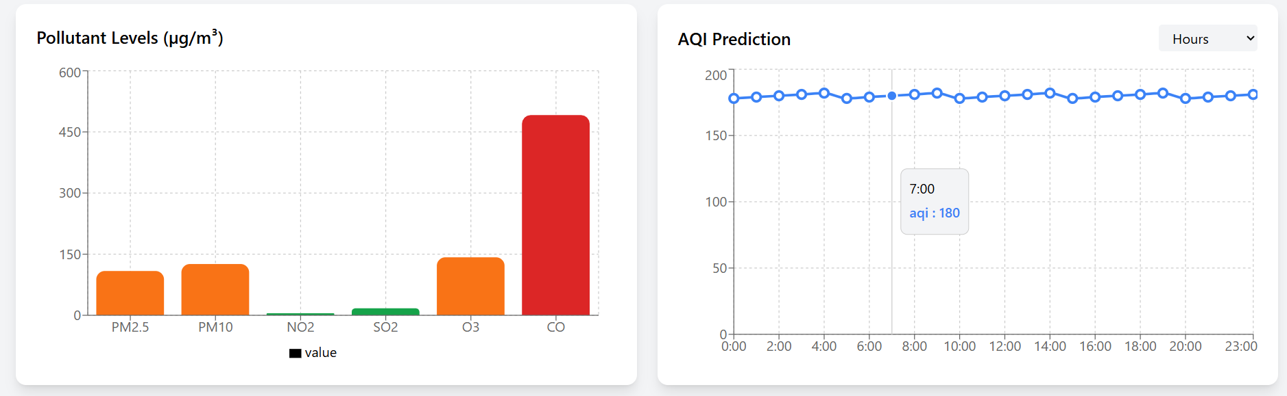

>> ABOUT PAGE

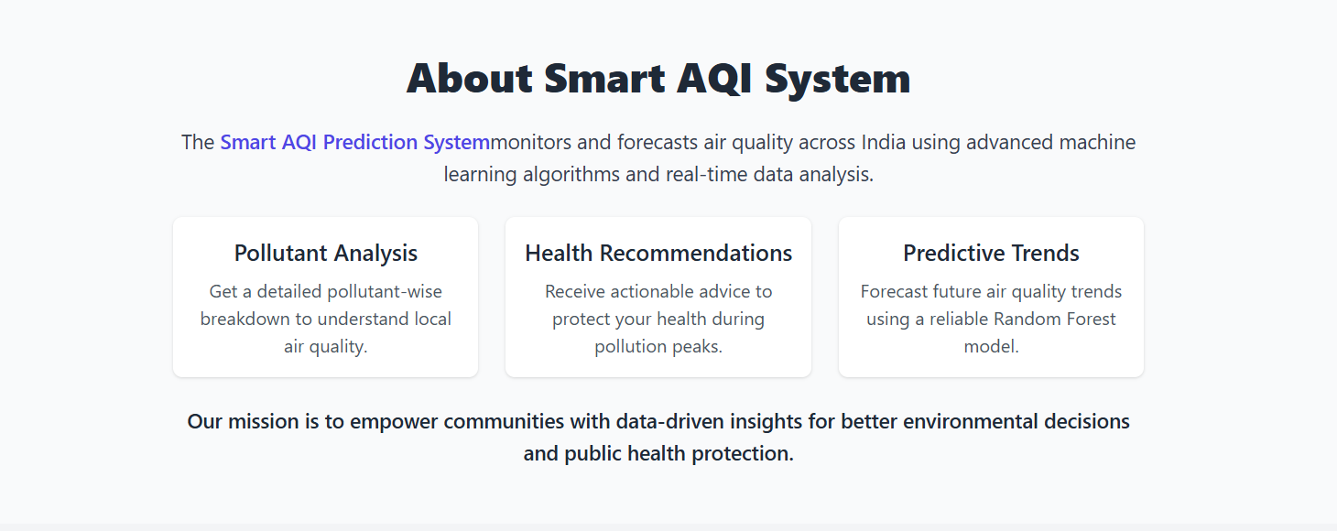

7. Challenges Faced

- Integration of Real-Time AQI Data: Handling real-time air quality data from external APIs required careful processing and error handling to manage inconsistent responses and API rate limits.
- AQI Calculation and Standardization: Converting raw pollutant concentration values into accurate AQI values while following standard air quality guidelines was a complex task.
- Data Quality and Missing Value: The historical air quality dataset contained missing and inconsistent data, requiring extensive preprocessing and feature selection before model training.
- Machine Learning Model Optimization: Selecting an appropriate regression model and tuning hyper-parameters to achieve reliable AQI predictions without over-fitting was challenging.
- Frontend–Backend Integration: Ensuring smooth communication between the React frontend and Flask backend, including handling CORS and API response formats, required careful coordination.
- Authentication and Security Implementation: Implementing secure user authentication with password hashing and JWT tokens while maintaining usability involved addressing security and session management issues.
- Performance and Response Time: Managing API response times and ensuring the dashboard updated smoothly without delays was challenging, especially when fetching real-time data and predictions.

8. Learnings & Skills Acquired

- Full-Stack Web Development: Gained hands-on experience in building a complete web application by integrating frontend technologies with backend services and databases.
- Frontend Development with React.js: Learned to create responsive and interactive user interfaces using React components, state management, routing, and modern UI libraries.
- Backend API Development using Flask: Acquired practical knowledge of designing and implementing RESTful APIs, handling client requests, and managing server-side logic.
- Database Management with MongoDB: Developed skills in storing, retrieving, and managing data using a NoSQL database and performing CRUD operations efficiently.
- Real-Time API Integration: Learned how to integrate and process real-time data from external APIs and handle errors, latency, and data inconsistencies.
- Machine Learning Model Development: Gained experience in data preprocessing, feature selection, model training, evaluation, and deploying machine learning models for predictions.
- Authentication and Security Practices: Learned secure authentication techniques such as password hashing, JWT-based session management, and environment variable handling.
- Data Visualization and Interpretation: Developed the ability to present complex data insights through charts, dashboards, and health indicators for better user understanding.
- Debugging and Problem Solving: Improved troubleshooting skills by resolving integration issues, environment setup errors, and runtime exceptions.
- Project Planning and Team Collaboration: Gained experience in project structuring, task coordination, documentation, and communicating technical ideas effectively within a team.

9. Testimonials from team

Ruchitha Mallela:

Working on the frontend of this project helped me strengthen my skills in React.js and UI design. I gained hands-on experience in building responsive dashboards and integrating real-time data visualizations.The project improved my understanding of component-based architecture and state management. Collaborating with the backend helped me learn how frontend and backend systems interact in real-world applications.

Rahul Kummara:

This project enhanced my practical knowledge of backend development using Flask and API design. I gained strong experience in integrating real-time APIs, implementing authentication, and managing MongoDB databases. I also developed skills in machine learning, including data preprocessing, model training, and deployment. Overall, the project improved my problem-solving ability and understanding of building scalable full-stack systems.

10. Conclusion

The Smart AQI Monitoring and Prediction System successfully integrates real-time air quality data, machine learning-based prediction, and a user-friendly interface to provide meaningful insights into air pollution levels. The project enhances public awareness, supports informed health decisions, and demonstrates the effective use of full-stack development and data-driven technologies to address real-world environmental challenges.

11. Acknowledgements

I would like to express my sincere gratitude to the Infosys Team for providing us with the opportunity, guidance, and resources to work on this project. Their support and structured environment played a crucial role in helping us understand real-world application development and industry practices.
I extend my heartfelt thanks to our project team members for their continuous collaboration, dedication, and mutual support throughout the project. The teamwork, idea sharing, and collective problem-solving efforts greatly contributed to the successful completion of this project.
I would like to convey our special thanks to our mentor, Mrs. Shakthi Gopalakrishnan, for his valuable guidance, encouragement, and technical insights. Her mentorship and constructive feedback helped us stay focused, overcome challenges, and improve the overall quality of the project.

